Extension 1: Water Source can only Change flow rate every 4 hours.

In this extension, the frequency of water source change flow rate is limited. In order to establish a particular formulation to add this constraint for the SAS architecture, we set a function ‘bs’ which represents ‘binary source’ to examine the cycle of source’s activity at least 4 hours. The mathematical formulation subject to the constraint is above. The variable ‘ns’ is not considered in this extension because it would not change and affect the constraint.

;

;

Among them,

;

;

.

The subtraction of two sources’ function is used to ensure the schedule can be divided by numeric 4 integrally when it implements the operation of flow rate transform. The right-hand formula determined the feasibility of flow rate change, the situation when the output value of function ‘bs’ equal zero would be rejected because the difference of two integers which greater than zero on the left hand cannot meet the requirement of inequality. In contrast, both of two reciprocal inequalities are true when ‘bs’ is one. In another word, only once in four hours for the design of sources schedule can change the flow rate, the sources would keep the same or similar flow rate in four hours which originate from the moment of the latest flow rate change till the next cycle. With the establishment of this constraint, the optimal solution still stayed in 1910.25 dollars. However, the distribution of source schedule has been changed refer to Figure 1. The flow rates produced by Cornwall WTP were normalized at the same rate in four hours per unit.

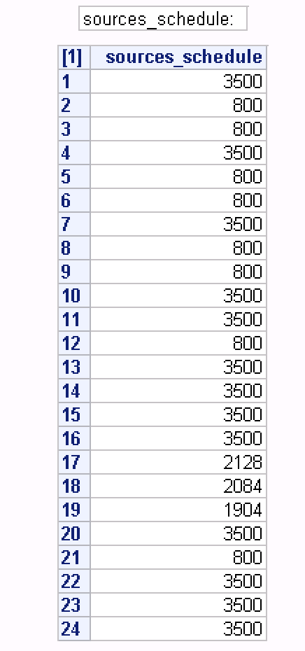 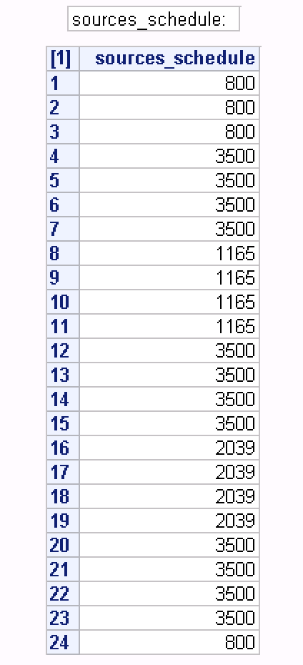

Figure 1. The sources schedule without constraint (left) and the sources schedule with constraint (right).

Extension 2: A pump has to run for at least 2 hours.

The modified problem formulation is built consist of 3 functions which represent three various moments in the pumps’ working process in this case. The function ‘pumps_schedule’ follows the Bernoulli distribution. It directs that ‘1’ for open and ‘0’ for close. The principle of this formulation is to verify if it is opened in all three moments, or closed in the second hour while the switch of pumps is opened either at the first hour of any period within 24 hours or the third hour. The variable ‘np’ does not vary in the whole process of iteration and will be not included. The specific formulations are as follows.

;

Among them,

;

.

According to these formulations, the function ‘pumps_schedule1’ (P1) refers to the status of pumps at the first hour, the same reason can be proved that ‘pumps_schedule2’ (P2), ‘pumps_schedule3’ (P3) represents the second and the third hour respectively. The sum of P1 and P2 (max 2) determines that the value of P2 would not be 1 when the left-hand formula is 0. The pumps have to run for not least than two hours based on this formulation and the performance of it illustrates in Figure 2 and 3. All the pumps were running more than two hours after modified and stayed in the same flow rate during its working period.

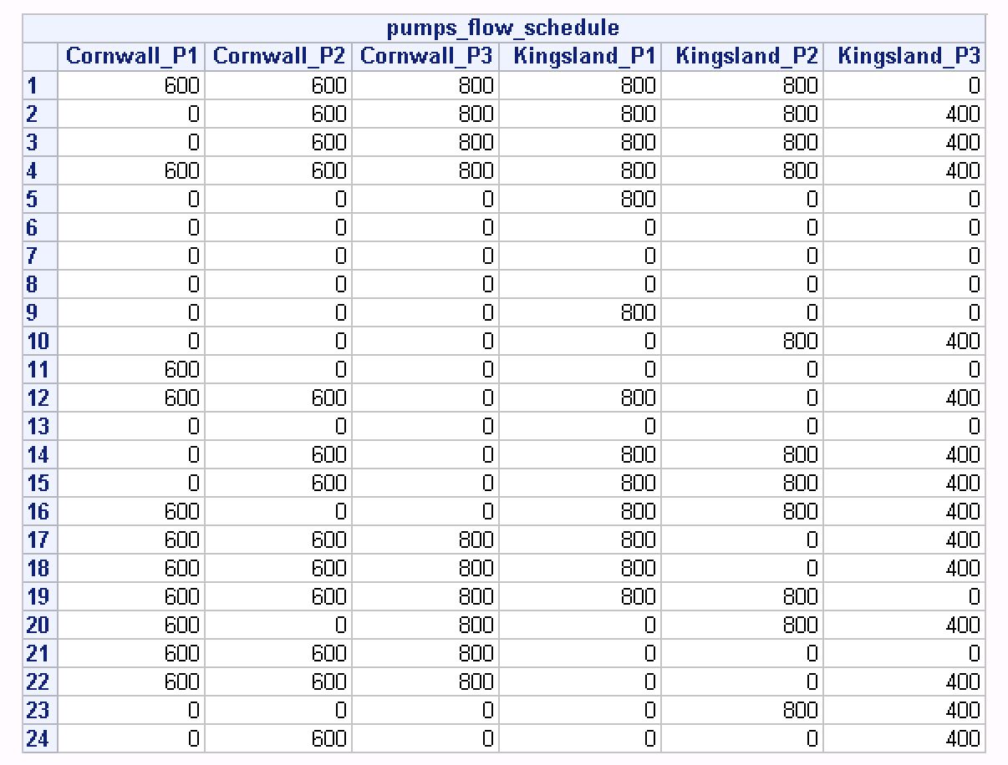

Figure 2. The performance of pumps before modified.

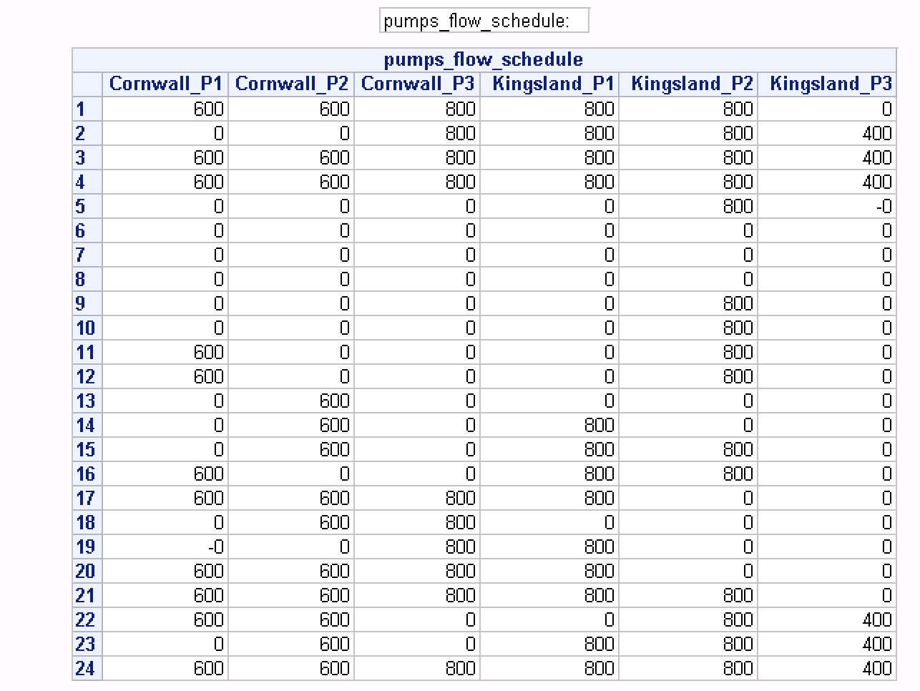

Figure 3. The performance of pumps after modified.

Extension 3: If a valve is open, it has to stay open at the same flow rate for at least 4 hours.

The connection established in this extension includes the decision of valves opening and the flow rate, which is controlled by valves. There are five binary variables set which are ‘valves_open’ and ‘bv’. The function ‘valves_open’ has been splitted into three variables which represent the situation for valves opening or closing in the first hour, the forth hours after the first hour and the ‘j’st hours after the first hour respectively. ‘bv’ is used to judge if the flow rate at the same level. ‘M’ is a huge integer number that it is available to expand the effect of function ‘bv’. The variable ‘nv’ is the valve node in the water distribution network, however, it will not be discussed in this extension due to its immutability.

;

;

;

;

;

Among them,

;

;

;

.

The first formulation indicates that the valves cannot be close between any period in four hours. Subsequently, the flow rate of the first hour is determined not more than 0 if it is closed. Furthermore, the inequality in reversed verification is used to ensure that the flow rate is maintained at the same water level from the first hour it is opened to the next hour. The effect of valves is optimized through this method which illustrates in Figure 4.

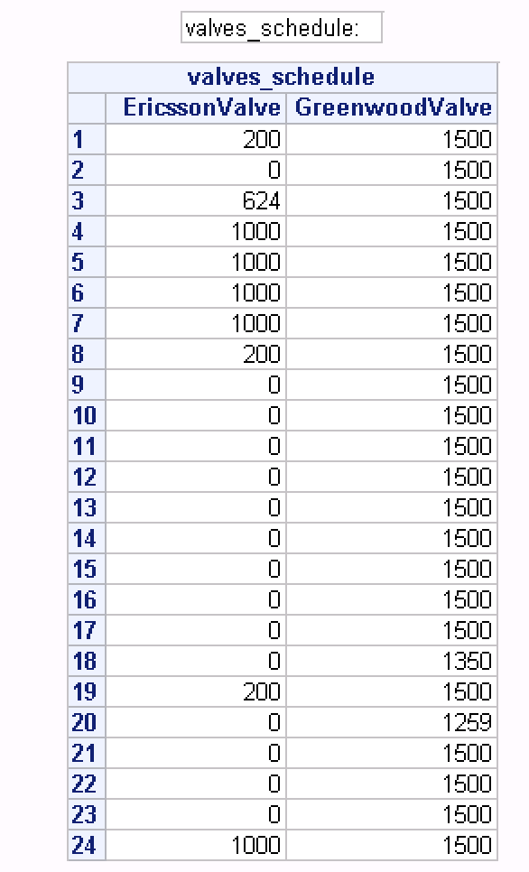 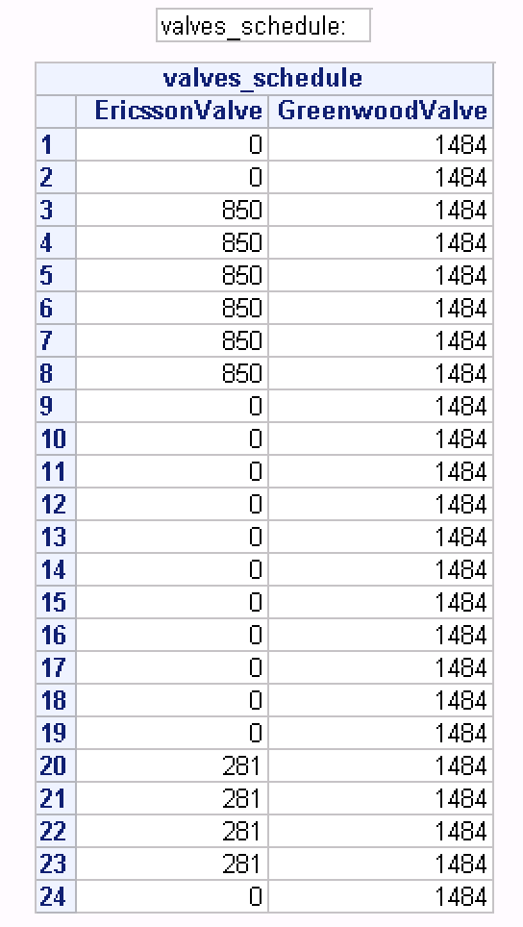

Figure 4. The flow rate in valves before modified (left) and after modified (right).